3-30 Main Question (สำหรับแสดงข้อสอบ)

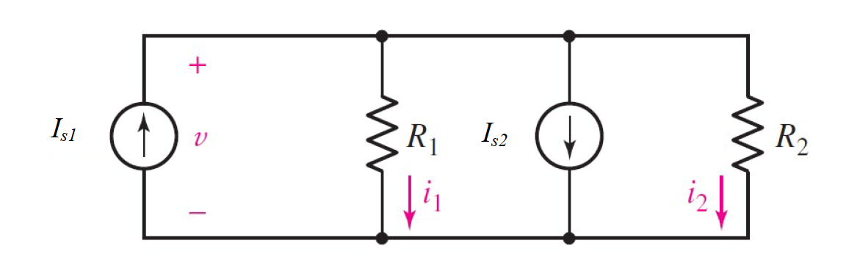

Given *IS*1 = 1 A, *IS* 2 = 2 A, *R*1 = 4 Ω, *R*2 = 2 Ω.

Find

Variables (สำหรับเขียนโค้ดเพื่อหาคำตอบ)

Random variables

IS1 = {1:5}; IS2 = {1:5};

R1 = {1:5}; R2 = {1:5};

Global variables

IS1 = 3; IS2 = 7; R1 = 4; R2 = 2;

V = (IS1-IS2)/(1/R1+1/R2);

Part (กรอกคำตอบ)

1. *V* = v = -5.333 V

3-31 Main Question (สำหรับแสดงข้อสอบ)



Given *IS*1 = -2 A, *IS* 2 = 3 A, *R*1 = 10 Ω, *R*2 = 6 Ω.

Find

Variables (สำหรับเขียนโค้ดเพื่อหาคำตอบ)

Random variables

IS1 = {1:10}; IS2 = {1:10};

R1 = {1:5}; R2 = {1:5};

Global variables

IS1 = 2; IS2 = 3; R1 = 10; R2 = 6;

V = (-IS1-IS2)/(1/R1+1/R2);

Part (กรอกคำตอบ)

1. *V* = v = -18.75 V

3-32 Main Question (สำหรับแสดงข้อสอบ)

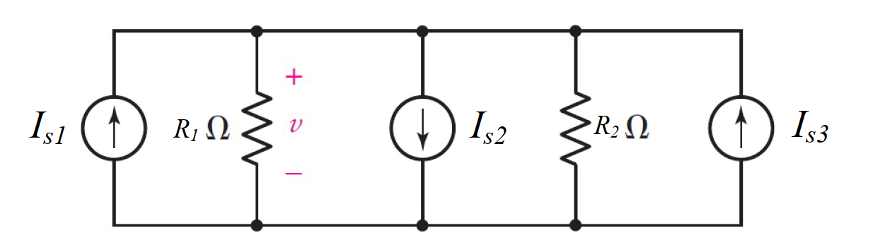

Given *IS*1 = 1 A, *IS* 2 = 5 A, *IS* 3 = 2 A, *R*1 = 5 Ω, *R*2 = 5 Ω.

Find

Variables (สำหรับเขียนโค้ดเพื่อหาคำตอบ)

Random variables

IS1 = {1:10}; IS2 = {1:10}; IS3 = {1:10};

R1 = {1:5}; R2 = {1:5};

Global variables

IS1 = 1; IS2 = 5; IS3 = 2; R1 = 5; R2 = 5;

V = (IS1-IS2+IS3)/(1/R1+1/R2);

Part (กรอกคำตอบ)

1. *V* = v = -5 V

3-33 Main Question (สำหรับแสดงข้อสอบ)

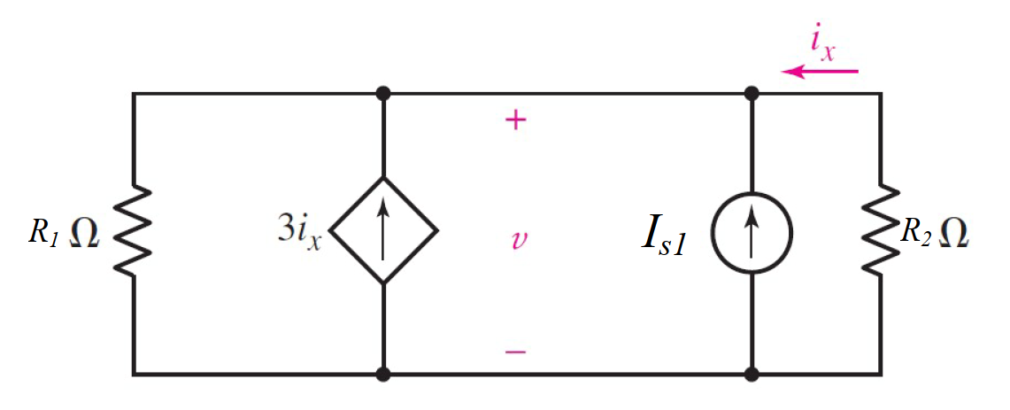

Given *IS*1 = 2 A, *R*1 = 1 Ω, *R*2 = 3 Ω.

Find

Variables (สำหรับเขียนโค้ดเพื่อหาคำตอบ)

Random variables

IS1 = {5:10};

R1 = {1:5}; R2 = {1:5};

Global variables

IS1 = 2; R1 = 1; R2 = 3;

V = IS1/((1/R1)+(1/R2)+(3/R2));

Part (กรอกคำตอบ)

1. *V* = v = 857 mV

3.34 Main Question (สำหรับแสดงข้อสอบ)

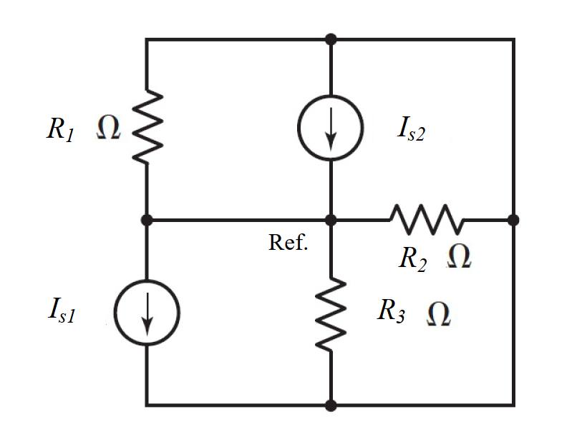

Given *IS*1 = 5 A, *IS* 2 = 3 A, *R*1 = 1 Ω, *R*2 = 4.7 Ω., *R*3 = 2.8 Ω.

Find

Variables (สำหรับเขียนโค้ดเพื่อหาคำตอบ)

Random variables

IS1 = {1:5}; IS2 = {1:5};

R1 = {1:5}; R2 = {1:5}; R3 = {1:5};

Global variables

IS1 = 5; IS2 = 3; R1 = 1; R2 = 4.7; R3 = 2.8;

V = (IS2-IS1)/((1/R1)+(1/R2)+(1/R3));

Part (กรอกคำตอบ)

1. *V* = v = -1.274 V